Report Title Asset Management Plan - Stormwater and Pump Stations

Report  Type | Decision
City Plan  Theme | Community  Environment & Heritage  Leadership
Report  Author | Manager Infrastructure Assets and Maintenance (City Assets)
Report  Summary | Council’s stormwater management plans have identified the need to invest $25,152,000 within the next 10 year financial planning period on new and significant upgrades to pump stations across the Council area.  This report recommends Council endorsement for these projects, along with including the increased expenditure in Council’s 10 Year Capital Works program.
Attachments | Nil

RECOMMENDATION

Council resolves that:

- The Director City Assets' report titled "Asset Management Plans - Stormwater and Pump Stations" be received and noted;

- Council endorse the construction of the Jetty Road Pump Station with a budget of $14,232,000 to be constructed across years 2024/25 and 2025/26;

- Council endorse the upgrade of the Wellington Street Pump Station with a budget of $10,920,000 to be constructed across years 2028/29 and 2029/30;

- An amendment be made to the 10 Year Expenditure table identified in Section 7 of the Pump Station Asset Management Plan, to include the expenditure of the Jetty Road Pump Station and upgrade of the Wellington Street Pump Station;

- An amendment be made to the 10 Year Expenditure table identified in Section 9 of the Stormwater Asset Management Plan, to include the expenditure upgrades to the existing stormwater network resulting from the approval of the Jetty Road Pump Station and upgrade of the Wellington Street Pump Station;

Report

Introduction

The current Pump Station Asset Management Plan, adopted by Council on the 10 November 2020, identified the need for significant expenditure in the following years:
- 2023/24 for the upgrade of the Midlunga Pump Station
- 2024/25 and 2025/26 for the construction of the Jetty Road Pump Station in the Lefevre Peninsula catchment,
- 2028/29 and 2029/30 for the Wellington Street Pump Station upgrades in the Port River East catchment.
The following Figure 1 was used in the Pump Station Asset Management Plan which depicted the expenditure and potential year required for these projects across the 10 year forecast period. Figure 1 further identified the need for a Council decision prior to formal allocation in Council’s Long Term Financial Plan (LTFP).

Each of these projects have already been workshopped and reported to Council through the outcomes of the Lefevre Peninsula and Port River East Stormwater Management Plans (SMP). Each corresponding Council report gained endorsement for the strategic approach to reducing the impacts of flooding as recommended by each SMP.

The Midlunga Pump Station upgrade had already been approved within the LTFP, and as such the required capital expenditure has already been budgeted for. This was an oversite at the time of preparing the Pump Station Asset Management Plan endorsed by Council at the 10 November 2020 meeting.

This report is now seeking the approval of Council to plan and construct the Jetty Road Pump Station across years 2024/25 and 2025/26 and further upgrade the Wellington Street Pump Station across years 2028/29 and 2029/30 to enable the budget requirements to be amended in the Asset Management Plans and will inform the Long Term Financial Plan.

All adjustments to the LTFP are detailed in Table 2 of this report.

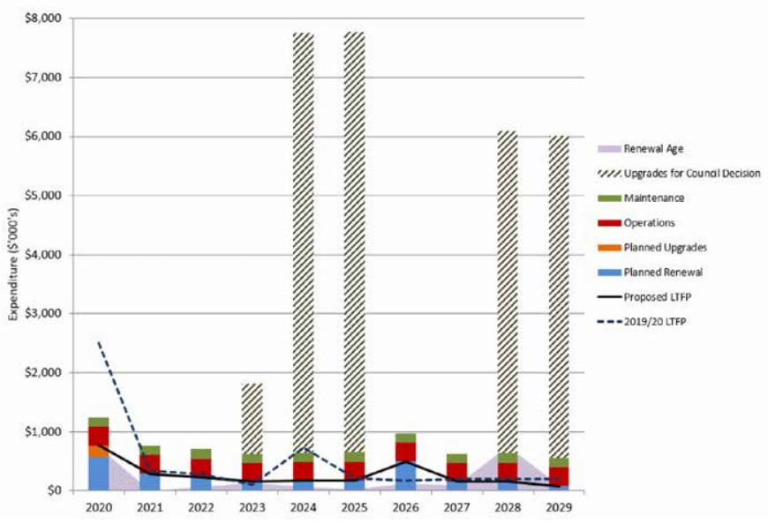
Figure 1 – Projected Operating and Capital Expenditure for Pump Stations Background

At its meeting on 10th November 2020, Council resolved that:

- The Director City Assets' report titled "Adoption of Asset Management Plans for Roads, Footpaths, Stormwater, Pump Stations and Parks and Gardens" be received and noted.
- The 2020 revision of Asset Management Plans as provided as Attachments 1 to Attachment 5 to the report titled "Adoption of Asset Management Plans for Roads, Footpaths, Stormwater, Pump Stations and Parks and Gardens" be adopted by Council.

Strategic requirements of the Stormwater Management Plan

Construction of the Jetty Road/Lulu Street Pump Station and upgrade of the Wellington Street pump station are highlighted as being medium and high priority works in their respective SMP’s. These works are required in order to provide significant flood reduction in the areas of Peterhead, Largs Bay, Largs North, Queenstown and Alberton.
Without the construction of this critical infrastructure there is little that Council will be able to do to reduce flood risks in these catchments. The proposed upgrades will allow Council to achieve a 1 in 20 year (5%AEP) standard where no above floor flooding will occur in these catchments. Figure 2 and 4 are examples of the flooding predicted for the 1 in 20yr storm for the Jetty Road/Lulu Street and Wellington Street pump station projects. The areas circled in black indicate locations of significant flooding.

Figure 3 and 5 show the potential flood benefits for the 1 in 20yr Average Recurrence Interval (ARI) storm event circled in black. It can be seen that there is a significant benefit from installation of a pump station for the Jetty Road/Lulu Street catchment and following the proposed upgrades to the Wellington Street pump station.

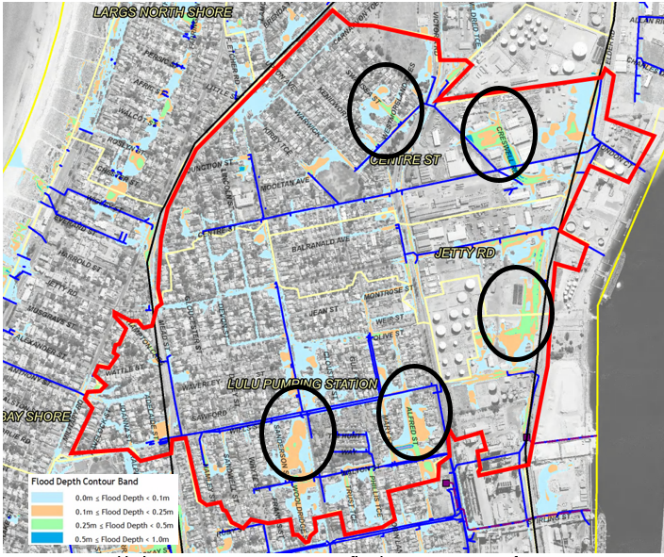
Figure 2 – Jetty Road/Lulu Street Pump station 1 in 20yr ARI flood mapping assuming ultimate infill development with the existing infrastructure

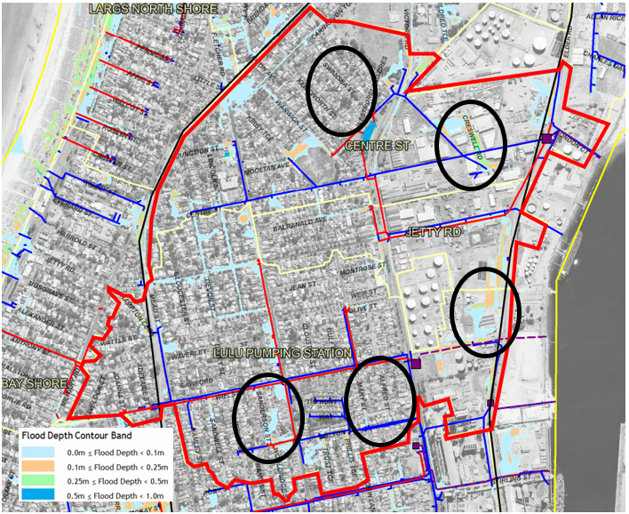
Figure 3 – Jetty Road/Lulu Street Pump station 1 in 20yr ARI flood mapping including new pump station and upgraded infrastructure
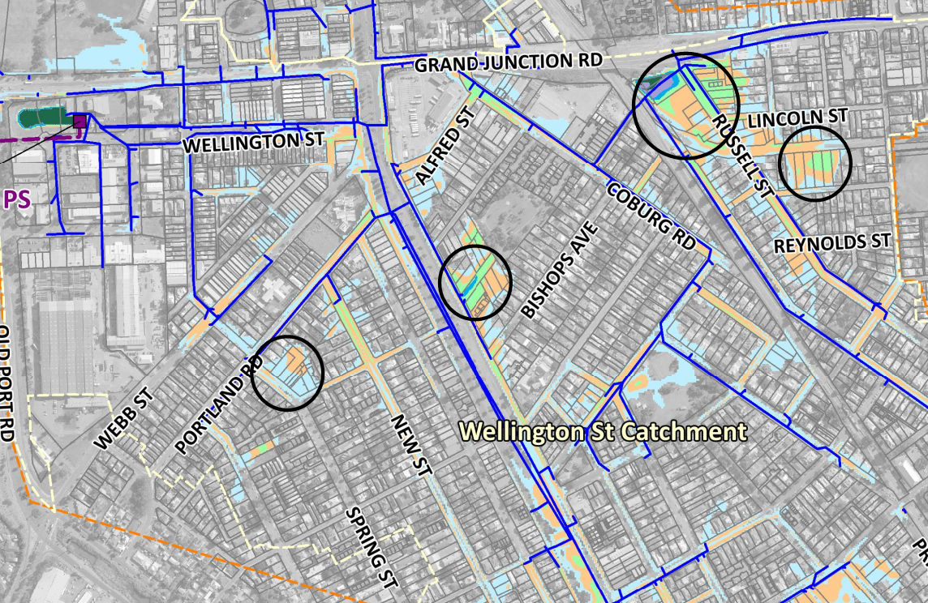
Figure 4 – Wellington Street Pump station 1 in 20yr ARI flood mapping assuming ultimate infill development with the existing infrastructure

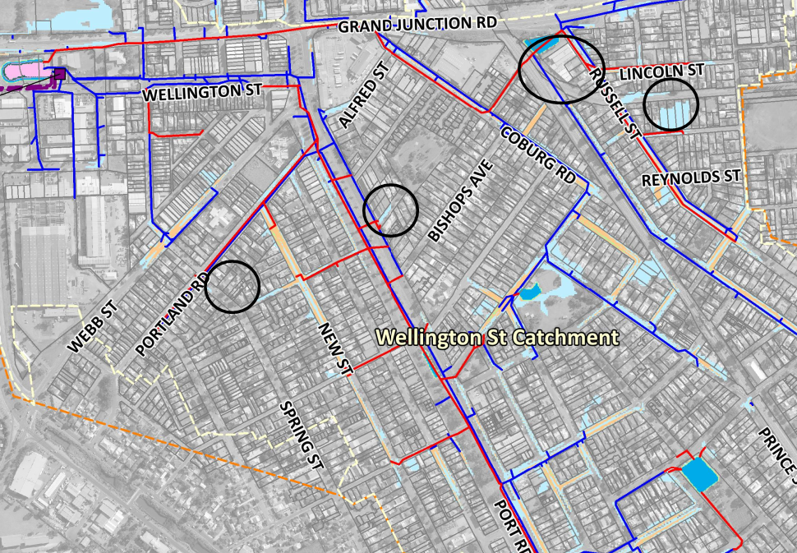
Figure 5 – Wellington Street Pump station 1 in 20yr ARI flood mapping assuming ultimate infill development with the upgraded infrastructure
As a part of the SMP, flood damage costs associated with peak storm events are estimated using the inundation depth and property value information. The data shown in Table 1 includes the “do nothing scenario” which assumes ultimate development with no change to the stormwater infrastructure for the 1 in 20yr and 1 in 100yr ARI storm events. It also shows the scenario with ultimate development and assuming the proposed upgrades are undertaken.
As shown in Table 1 that undertaking the pump station upgrades would reduce the potential damages across these two catchments from $55.6million to $28.3million.

Table 1 – Flood Damages reduction
 | Existing Infrastructure Scenario |  | Proposed Upgrade Scenario
 | 20yr Storm | 100yr Storm | 20yr Storm | 100yr Storm
Jetty Rd/Lulu St | $4,617,643 | $11,519,790 | $969,000 | $3,599,000
Wellington St | $17,493,749 | $40,679,267 | $2,113,000 | $22,195,000
Total | $23,597,579 | $55,621,785 | $3,622,000 | $28,283,000

The damage estimates do not take in to account the ‘intangible damages’ which relate to the physical and mental health of people impacted by flooding. Residents particularly in the Jetty Road/Lulu Street catchment area have been impacted by flooding on numerous occasions over the last six years and as such the intangible damages in this area are rated as being extremely high.

City Plan Relationship

Council prepares comprehensive AMPs in order to ensure that it is able to continue to deliver the services, programs and public infrastructure that support the vision of the City Plan 2030. Through demonstrating Leadership, these plans ensure our assets and infrastructure are planned for and managed sustainably across the region.
The proposed upgraded infrastructure are required in order to ensure address infill development and climate change, as well as providing a safe flood resilient community.

Legislative Context and Related Policies

Council’s 2020 AMPs have been developed in compliance with Section 122 of the Local Government Act 1999. AMPs are key strategic management plans which inform Council’s Long Term Financial Plan.
The Local Government Association Act 1999 schedule 1A, Section 17 and 18 detail the requirements of Council to undertake Stormwater Management Plans in accordance with the Stormwater Management Planning Guidelines.
The following policies are also applicable to this report:
- Local Government (Stormwater Management) Amendment Act 2007
- Urban Stormwater Management Policy for South Australia 2005

Stakeholder Engagement

The construction of the Jetty Road/Lulu Street and the upgrade of the Wellington Street pump station are part of a broad strategy of upgrading specific stormwater related infrastructure as identified in the Lefevre Peninsula and Port River East SMPs. The need for this strategic action is to protect the current and future community from flooding resulting from both infill development and climate change.
Stakeholder engagement was undertaken at the time of communicating the findings of the SMPs prior to gaining Council endorsement for both previous Council reports:
- Lefevre Peninsula SMP, 14 November 2017, item 12.2.14
- Port River East SMP, 12 November 2019, item 12.2.9
Stakeholder engagement is anticipated as part of the process in preparing the LTFP prior to seeking Council endorsement. Any adjustments causing an addendum to the Stormwater AMP and Pump Station AMP resulting from the recommendation of this report will be used to model the expenditure requirements for the LTFP.

Risk Management

The AMPs are key strategic management plans that guide Council’s long term financial performance. Each plan further identifies risks associated with each infrastructure type, and the process of mitigating any unacceptable risks through planned maintenance or capital projects.

Financial Management

The purpose of each AMP is to project the required funding levels to sustain or improve services over a ten year forecast period. The expenditure projections within each plan inform the long term financial plan.
Should Council endorse the recommendation of this report, Table 2 identifies the adjustments to the combined pump station and stormwater 10 year long term financial plan.

Table 2 – Adjustments to 10 Year Capital Program
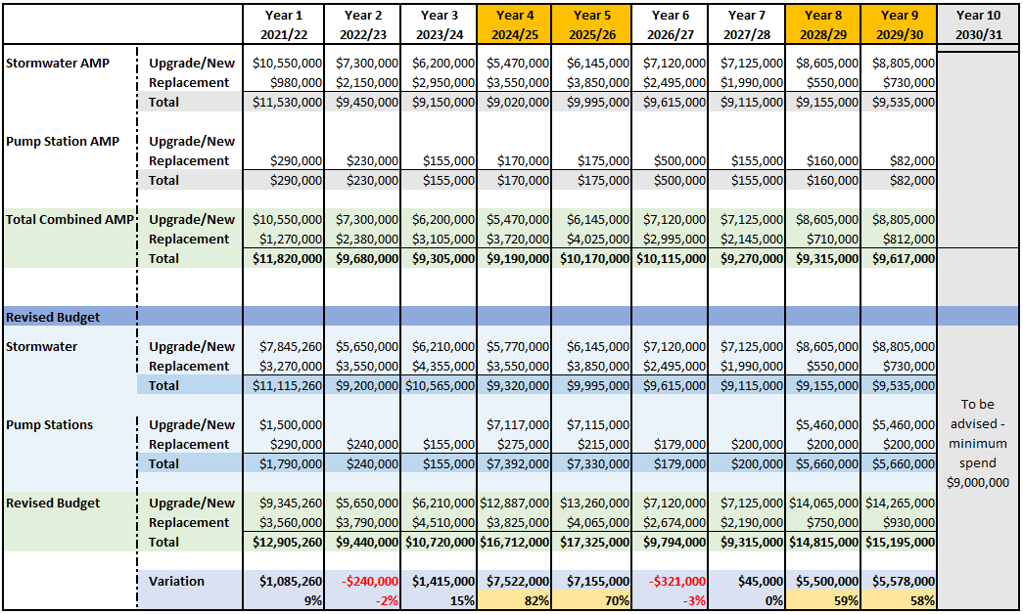

Variation Notes:
- 2021/22 (9%) - Change in budget due to approved additional expenditure for Dover Street Open Space Project.
- 2023/24 (15%) - Kolapore Ave project was originally programmed for 2021/22 however rescheduled for 2023/24 to allow for an obstructing gas service to be made obsolete in the next year and a half.
- 2024/25 (82%) – Construction of Jetty Rd/Lulu Street Pump Station
- 2025/26 (70%) - Construction of Jetty Road/Lulu Street Pump Station
- 2028/29 (59%) – Upgrade of Wellington Street Pump Station
- 2029/30 (58%) - Upgrade of Wellington Street Pump Station

Further to the Capital costs associated with the Jetty Road/Lulu Street and Wellington Street Pump Station projects, the operational/life cycle costs associated with depreciation and ongoing maintenance is further considered.

Depreciation Expense
Given that depreciation is a calculation based on an assets useful life, the following calculation is indicative only due to the complexity of factoring the many components of a pump station which have lives varying from 15 years for hoists and sensors, 20-35 years for mechanical pumps, 40 years for generators, and 60 years for pits and gantries. As there is no current design of either Pump Station it is difficult to calculate operating expenses without fully understanding the type of componentry that would exist in the final design. Accordingly, the following calculations are based on the Hargrave Street Pump Station, constructed in 2015, where an average depreciation rate has been used as a guide.

Table 3 – Indicative Depreciation using the Hargrave Street Pump Station as a guide
 | Replacement Value | Annual Depreciation Expense | Depreciation Rate (%)
Hargrave Pump Station | $8,651,199 (valuation) | $168,596 | 2%
Jetty Rd Pump Station (New) | $14,232,000 (budget) | $284,640 | 2%
Wellington St Pump Station (Upgrade component) | $10,920,000 (budget) | $218,400 | 2%
TOTAL |  | $503,040
Note: estimates for the annual depreciation are an estimate only. Future Fair Value as per AASB 13 & 116 is likely to be less than allocated capital budget given no account for excavation, dewatering, etc., and as such the annual depreciation expense is assumed to be between Hargrave Street Pump Station and values provided for the two new pump station assets.

It must further be noted that the operating expense values above are indicative only. The increase to the depreciation record for the stormwater network cannot be calculated without a final design and would be considered minor given that this type of infrastructure have extensive lives of approx. 100 years and will contribute to a network of 518 km’s with a current replacement value of $442.6 million and an annual depreciation expense of $4.7 million (as at 30 June 2019).

Having regard to the deprecation relating to the upgrade/new expenditure itemised in Table 2, the total stormwater spend actually reduces in the ‘revised’ program across the 9 years by $4,494. This results in a minor change to the current stormwater network annual depreciation when considering the revised expenditure for stormwater against what was adopted in the AMPs in November 2020.

When considering the increase to the revised pump station upgrade/new program, the total expenditure resulting from the works associated with the three pump stations is $26 million. The annual depreciation from the pump stations [with an averaged useful life of 50 years] will potentially increase by approximately $533,000 per year, which is in line with the suggested deprecation in Table 3 when calculated at 2%. This value is based on the total Current Replacement cost being calculated by budgeted amount, and not using the fair value method.

As at 30 June 2019, the current replacement cost of Council’s existing 11 pump stations was valued at $26.2M, with annual depreciation expense recorded at $610,500.

Maintenance Expense
The addition of one new pump station along with a significant upgrade of a second pump station, on Council’s existing inventory of 11 pump stations, is likely to increase Council’s maintenance expenditure on pump stations by approximately 15% as shown below.

2020/21 Adopted Maintenance Budget $476,100
15% increase $71,415
Total $547,515

Long Term Financial Plan

Figure 6 – Projection of total Capital Expenditure
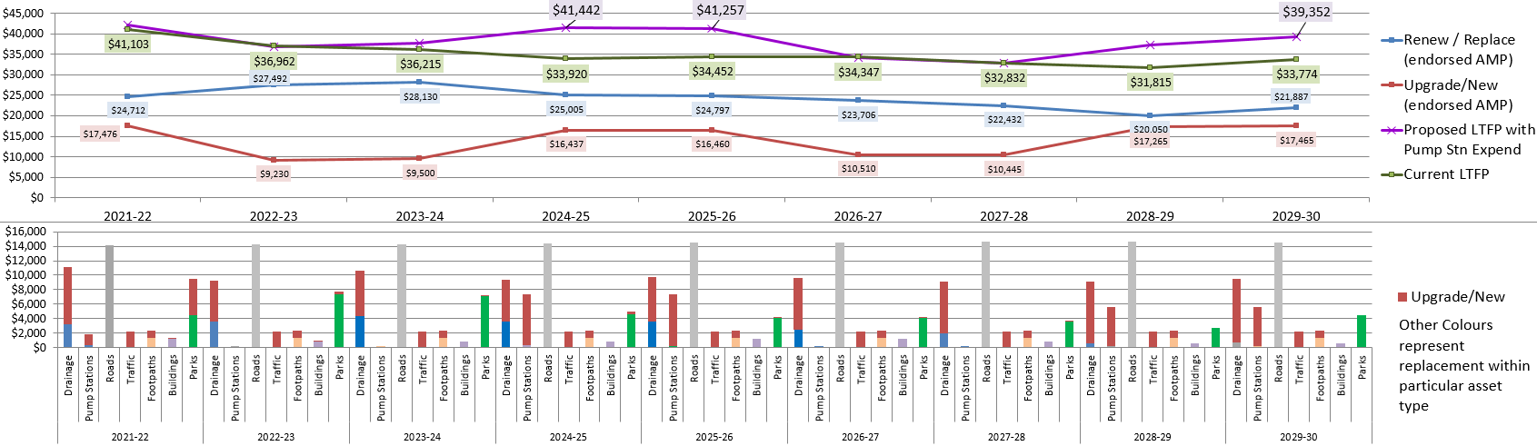

Should Council support the construction of the pump stations, the purple line in figure 4 depicts the increase in capital expenditure for the projected term relative to the current LTFP (green line).

It is important to note that this report relates only to the critical infrastructure required to reduce the impacts of localised flooding as modelled within the recent SMP studies. The figure 6 graph must be considered in isolation to other Council reports recommending further variation to other asset class capital works programs.

Environmental and Social Impacts

A key focus of Council’s Asset Management Strategy is realising the ‘public good’ (which includes the social and environmental value) that is delivered via our assets and the services they support. As stated earlier the proposed projects are considered to reduce ‘intangible damages’ which relate to the physical and mental health of people impacted by flooding. Residents particularly in the Jetty Road/Lulu Street catchment area have been impacted by flooding on numerous occasions over the last six years and as such the intangible damages in this area are rated as being extremely high.

