Report Title Inclusive Sports Facilities Assessment Project - Action Plans

Report  Type | For decision
City Plan  Theme | Community  Placemaking  Leadership
Report  Author | Social Planner (Corporate Services)
Report  Summary | This report provides an action plan for the next 10 years for Council’s active sporting facilities based on the findings of the Inclusive Sports Facilities Assessment Project. Actions include capital investment as well as additional work, such as further investigations for site Master Planning.
Attachments | Attachment 1 – Priority Action List  Attachment 2 – Site Action List (by Ward)  Attachment 3 – Project update for clubs

RECOMMENDATION

Council resolves that:

1. The Director Corporate Services report titled "Inclusive Sports Facilities Assessment Project – Action Plans" be received and noted.

2. The Site Action Plans be adopted for inclusion in the relevant Asset Management Plans.

3. The Asset Management Plan – Buildings and Asset Management Plan – Parks and Gardens are reviewed accordingly and tabled for adoption at the Council Meeting on 11 May 2021.

Report

At its meeting on 9 March 2021, Council resolved as follows:

1. The Director Corporate Services report titled "Inclusive Sports Facilities Assessment Project" be received and noted.

2. The following capital projects and funding be included for consideration in the draft Annual Business Plan and Budget for 2021/22:

Greenacres Reserve – New clubrooms (scope and design) with funding of up to $271,200.
TK Shutter Reserve – Upgrade change rooms (scope and design) with funding of up to $162,700.

3. That it is noted grant applications have been submitted for the following projects identified as priority works within the audit:
Gepps Cross Reserve – Upgrade change rooms
Port Adelaide Reserve – New athletics throw cages
St Albans Reserve – New athletics throw cages
EP Nazer Reserve – Baseball fencing
Greenacres Reserve – Tennis Courts
Largs Reserve – Oval lighting
Port Reserve – Practice nets

The March 2021 Council Report indicated that Site Action Plans would be provided to the April Council meeting for adoption. Actions have been identified for each reserve based on the findings of the Assessment in relation to buildings, key sporting infrastructure, sports lighting and the carrying capacity of grounds, as well as discussions with the relevant state sporting organisations. Attachment 1 provides a list of all proposed actions with indicative timelines and costings. Attachment 2 provides this information by reserve and Council Ward.

The Action Plan has been developed based on an assessment of a variety of factors including the:
- Relative overall priority of each site
- Condition and level of performance of buildings and sports infrastructure
- Levels of Club activity/participation
- Peak sporting body strategy (where relevant)
- Staging of larger projects to allow a detailed project scope to be presented to Council before the project proceeds to construction
- Areas/facilities where further information and investigation is needed

The Actions will be incorporated into the relevant Asset Management Plans (Buildings and Parks and Gardens) which will be presented to the May 2021 Council Meeting.

City Plan Relationship

This project relates to the City Plan in the following ways:
- Community – providing safe and welcoming sporting facilities which promote health and wellbeing, encourage participation and support community connection. This project has been identified as a priority to achieve the Community Vision.
- Placemaking – supports the delivery of active places and spaces, working with local clubs and peak sporting bodies to provide a variety of well-maintained sporting opportunities for the community
- Leadership – development of an evidence-based program to ensure that Council owned sporting facilities meet the needs of the community now and into the future.

This project also relates to the following Council strategic plans:
- Sports Development Plan 2017-2022
- Open Space Strategy 2021-2026
- Active Recreation Facilities Plan
- Asset Management Plan – Buildings
- Asset Management Plan – Parks and Gardens

Legislative Context and Related Policies

This project enables Council to more effectively prepare its Asset Management Plan – Buildings and Asset Management Plan – Parks and Gardens in relation to its active sporting facilities, as well as its Long Term Financial Plan to ensure that Council’s sporting assets are fit-for purpose, encourage participation, meet the needs of the community, and address the standards required by various sporting codes.

Stakeholder Engagement

This project has involved extensive engagement with clubs who use Council’s sporting facilities, including and survey of clubs. Elected Members have been engaged through Ward briefings and an Elected Member Workshop as part of the Annual Business Planning and Budget process.

Meetings have also now been held with a number of State Sporting Organisations to discuss the findings of the project to date, identify any gaps in information and ensure that proposed actions are in line with the future directions of the various sporting codes. Meetings have been held with:
- South Australian Cricket Association
- South Australian National Football League
- SA Rugby
- Tennis SA
- Bowls SA
- Netball SA
- Football SA
- NRL South Australia
A project update has been sent to Clubs (See Attachment 3) providing them with an update on the project, a summary of the findings, and information on where to access the findings and who to contact for further information. The update also encourages those clubs who have not submitted a survey and participation data to do so.

Risk Management

This project will assist in reducing risk to Council regarding the quality of its sporting facilities by enabling evidence based planning for the provision of fit-for-purpose assets which meet the current and future needs of the community.

Financial Management

The audit findings will enable Council to more effectively manage its community sporting assets through prioritisation and planned implementation of asset replacement and facility improvement works. A program of capital works has been developed in response to the audit findings. The program has been cross-referenced against Council’s existing forward works programs comprised within adopted Asset Management Plans. The proposed program will require substantial additional expenditure above the levels indicated within Council’s adopted Long Term Financial Plan. This will discussed at a workshop on the Long Term Financial Plan, which will include funding options for the Action Plans.

The indicative financial impact of the identified works, in excess of adopted Long Term Financial Plan expenditure levels, is summarised as follows:

Proposed Additional 10-year Capital Investment ($million)
Category | Replacement | New/Upgrade | Total
Buildings | $4.09 | $23.53 | $27.62
Parks & Gardens | $3.31 | $1.93 | $5.24
Total | $7.40 | $25.46 | $32.86

Capital works cost estimates have been prepared utilising a combination of the following methods:

Category | Method
Building Upgrades | A standardised estimate formula has been developed comprising:  1) standard floorspace calculation for each facility component (i.e. change rooms, medical rooms, social facilities, toilets)  2) number of facility components within scope for each site  3) all-inclusive industry average construction unit rate applied per square metre  4) overhead cost added
Building Refurbishment | A concept estimate has been prepared for each refurbishment project comprising:  1) applicable floorspace at each building  2) relevant industry construction unit rate applied per square metre  3) builder’s preliminaries and margin, contingency, design allowances and overheads added
Sports Infrastructure | Known estimated costs based on recent tendered renewal works utilising a standard scope of works for each site.

An analysis of operating costs associated with the identified works has also been undertaken, and is summarised as follows:

Capital and Operating Impacts for Buildings and Parks & Gardens |  | 2021/22 | 2022/23 | 2023/24 | 2024/25 | 2025/26 | 2026/27 | 2027/28 | 2028/29 | 2029/30 | 2030/31
Total Capital Cost Impact |  | $1,837,000 | $4,671,100 | $4,990,300 | $5,384,800 | $5,363,300 | $4,603,360 | $3,064,440 | $1,782,200 | $1,798,400 | $667,800
Operating Cost Impact | Depreciation | $33,955 | $113,842 | $121,203 | $104,854 | $112,182 | $90,164 | $75,640 | $33,244 | $46,147 | $6,239
 | Insurance | $2,500 | $5,000 | $5,000 | $7,500 | $10,000 | $10,000 | $10,000 | $2,500 | $7,500 | $2,500
 | Maintenance & Compliance | $1,500 | $3,000 | $3,000 | $4,500 | $6,000 | $6,000 | $6,000 | $1,500 | $4,500 | $1,500
 | Total* | $38,000 | $122,000 | $129,300 | $117,000 | $128,300 | $106,400 | $92,000 | $37,300 | $58,300 | $10,300
Combined Total Impact |  | $1,875,000 | $4,793,100 | $5,119,600 | $5,501,800 | $5,491,600 | $4,709,760 | $3,156,440 | $1,819,500 | $1,856,700 | $678,100
* Figures have been rounded for budget purposes

The following graph shows the accumulating new operating expenditure from new capital facilities.

Environmental and Social Impacts

The outcomes of this assessment will support Council to make well informed and prioritised decisions regarding the adequate and appropriate provision of sporting facilities across the City. These facilities play a vital role in promoting community wellbeing, physical activity and community connection.

ATTACHMENT 1
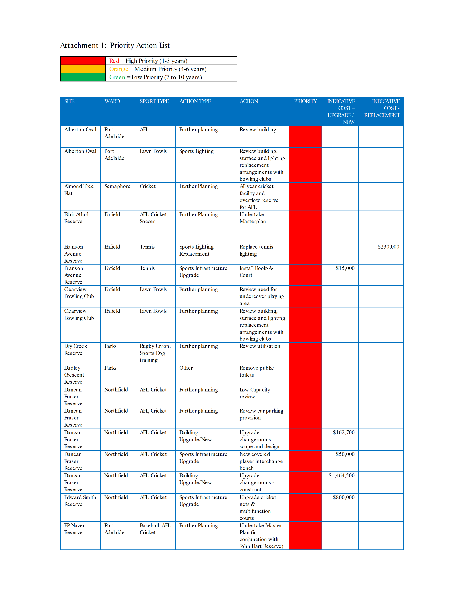
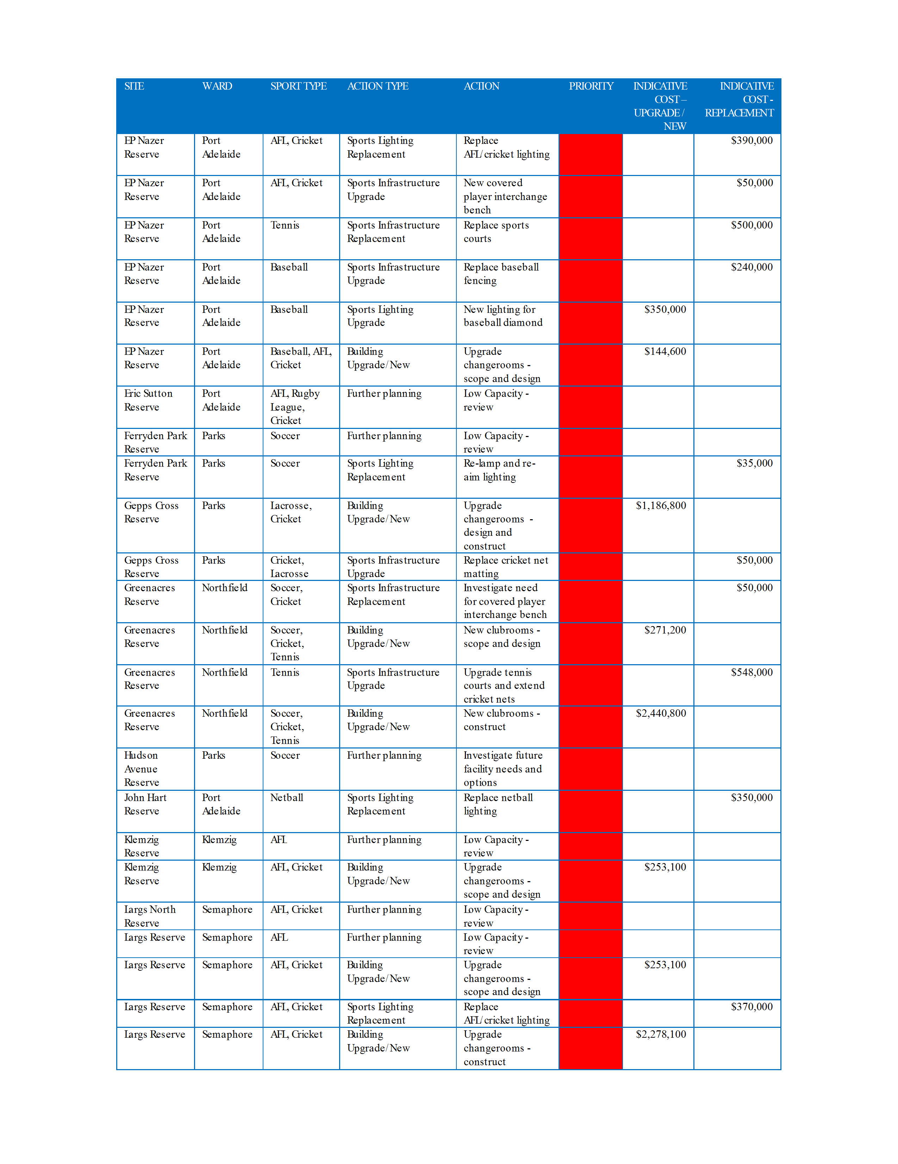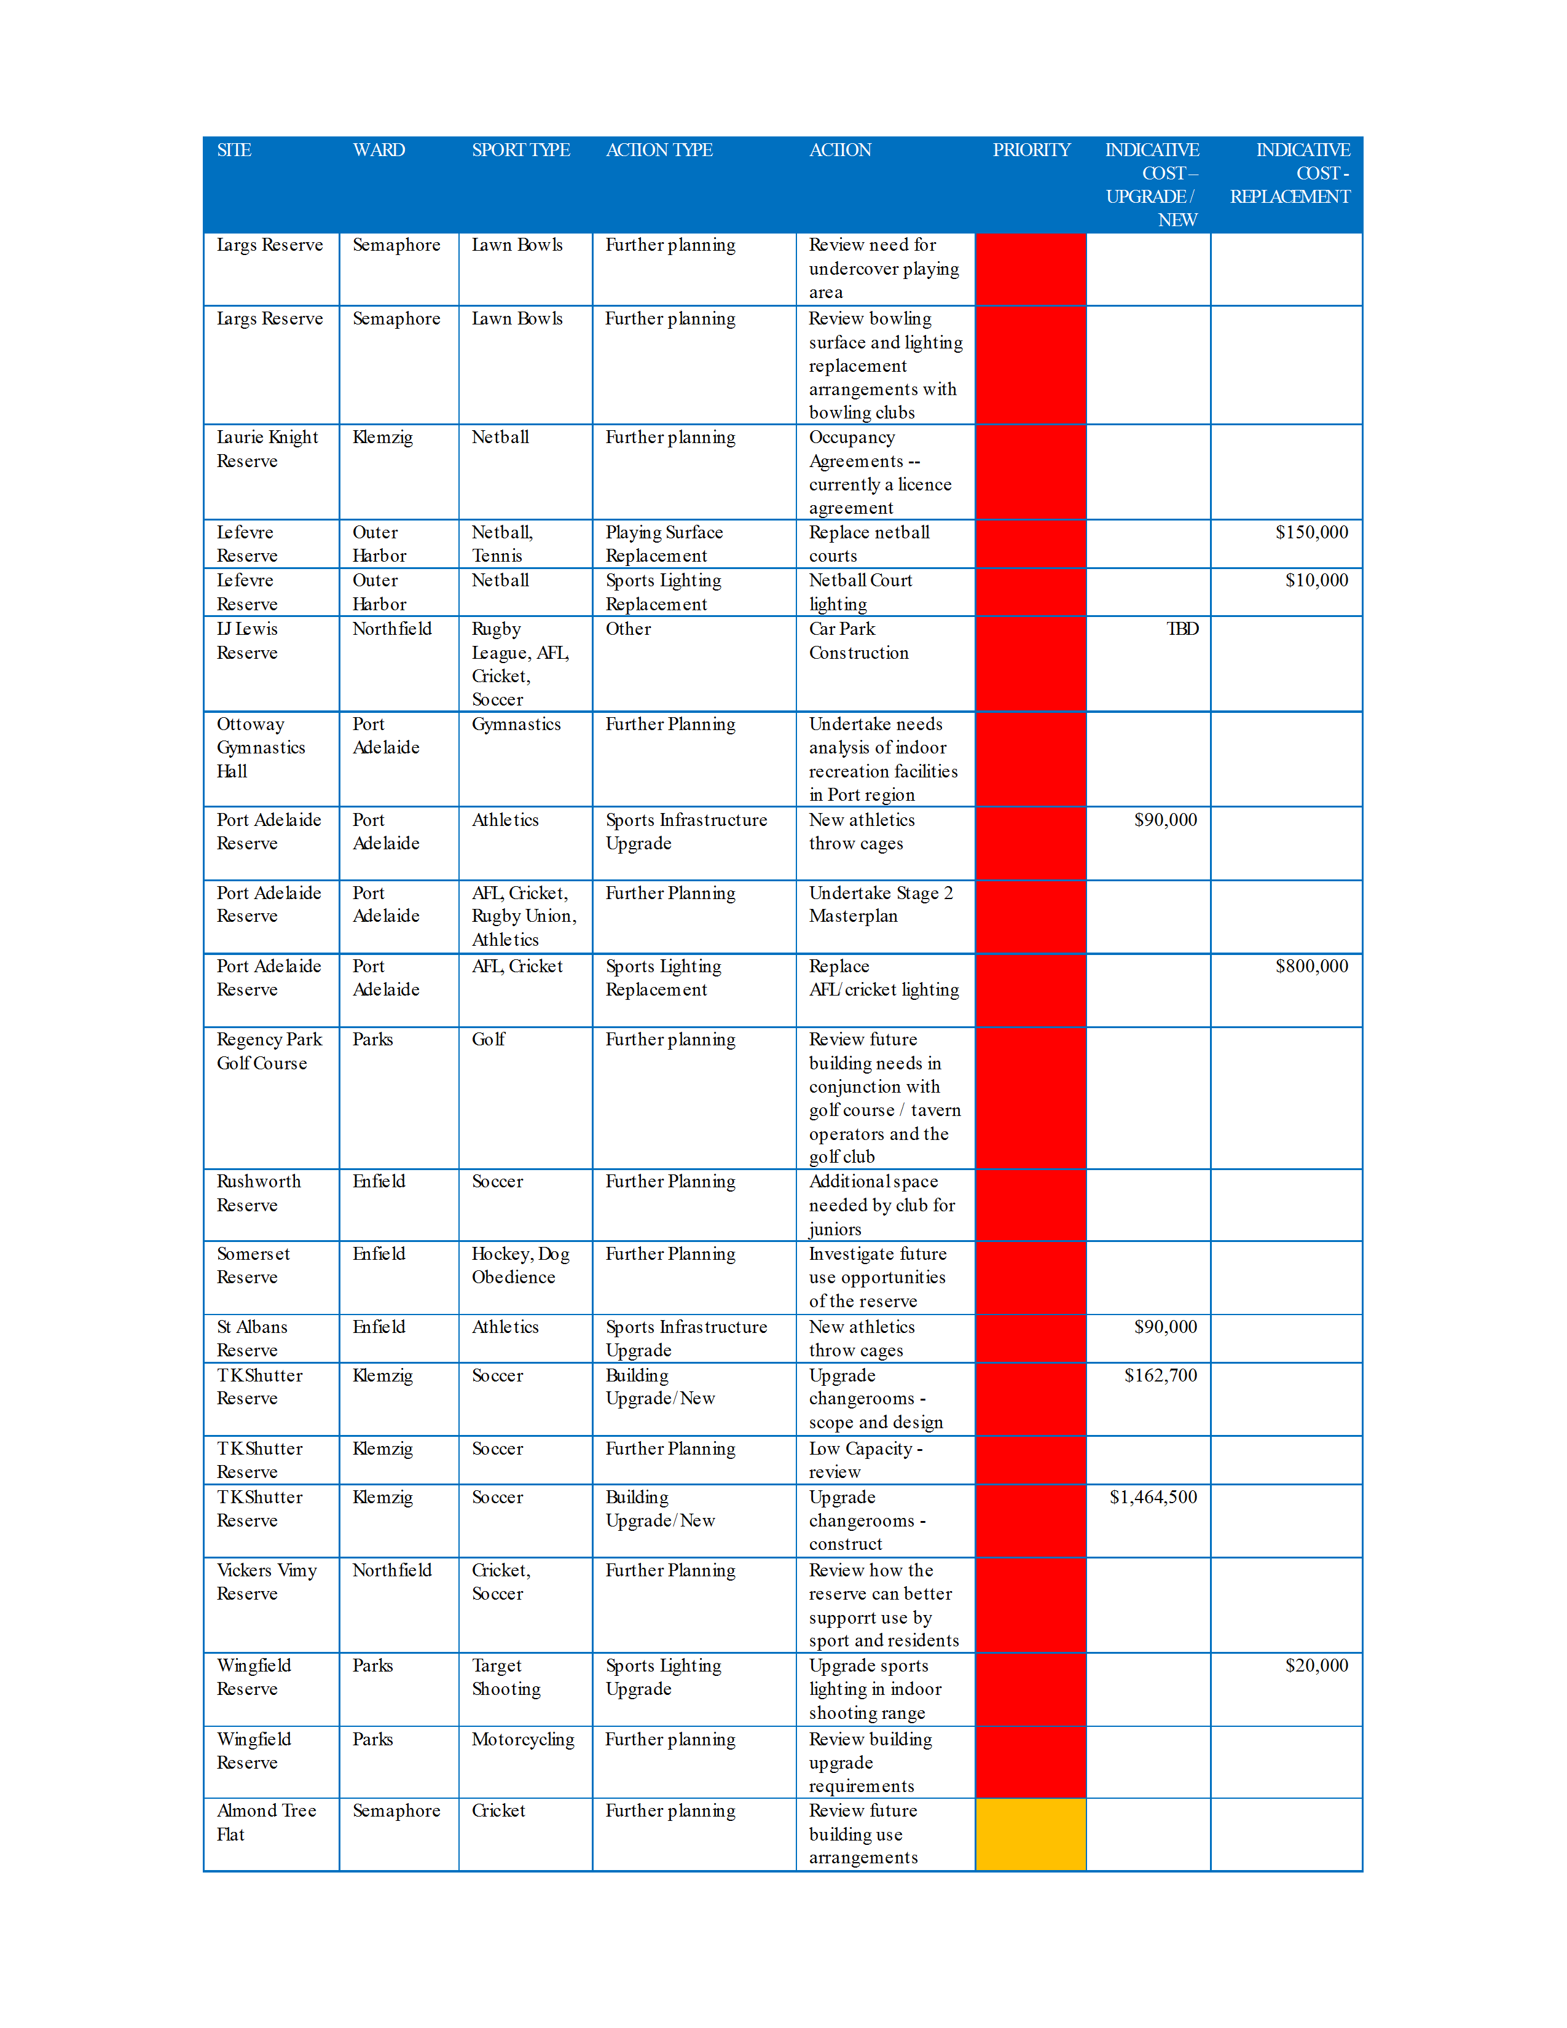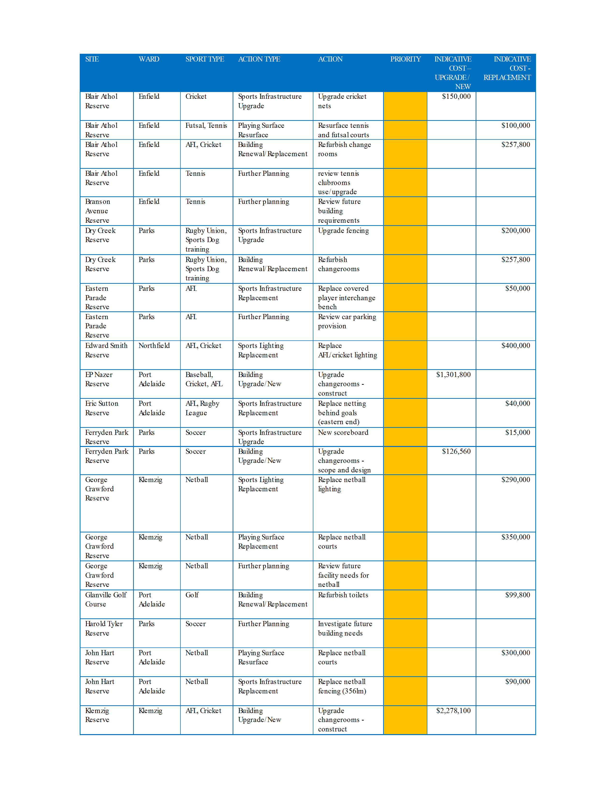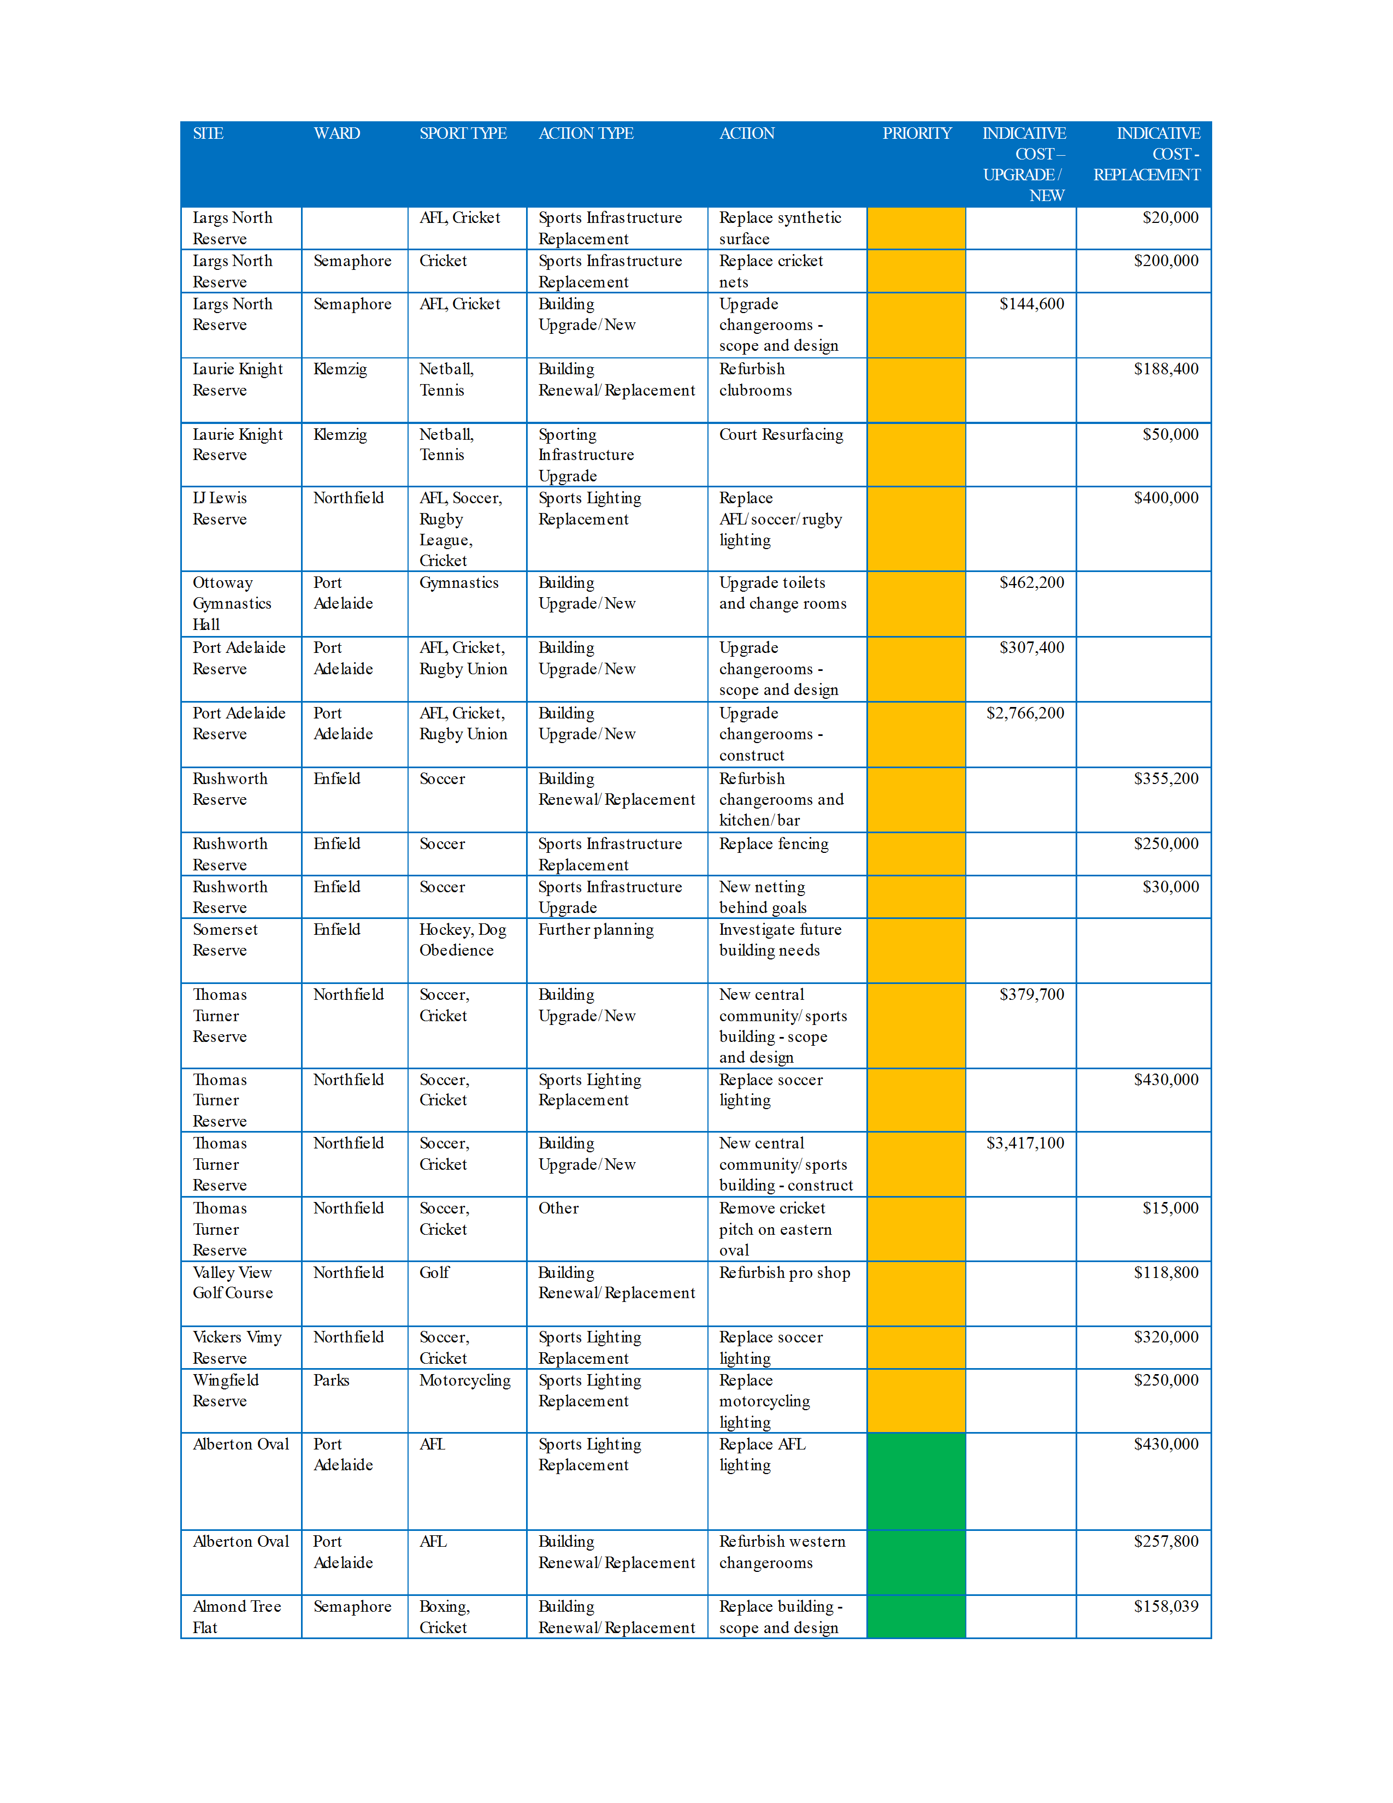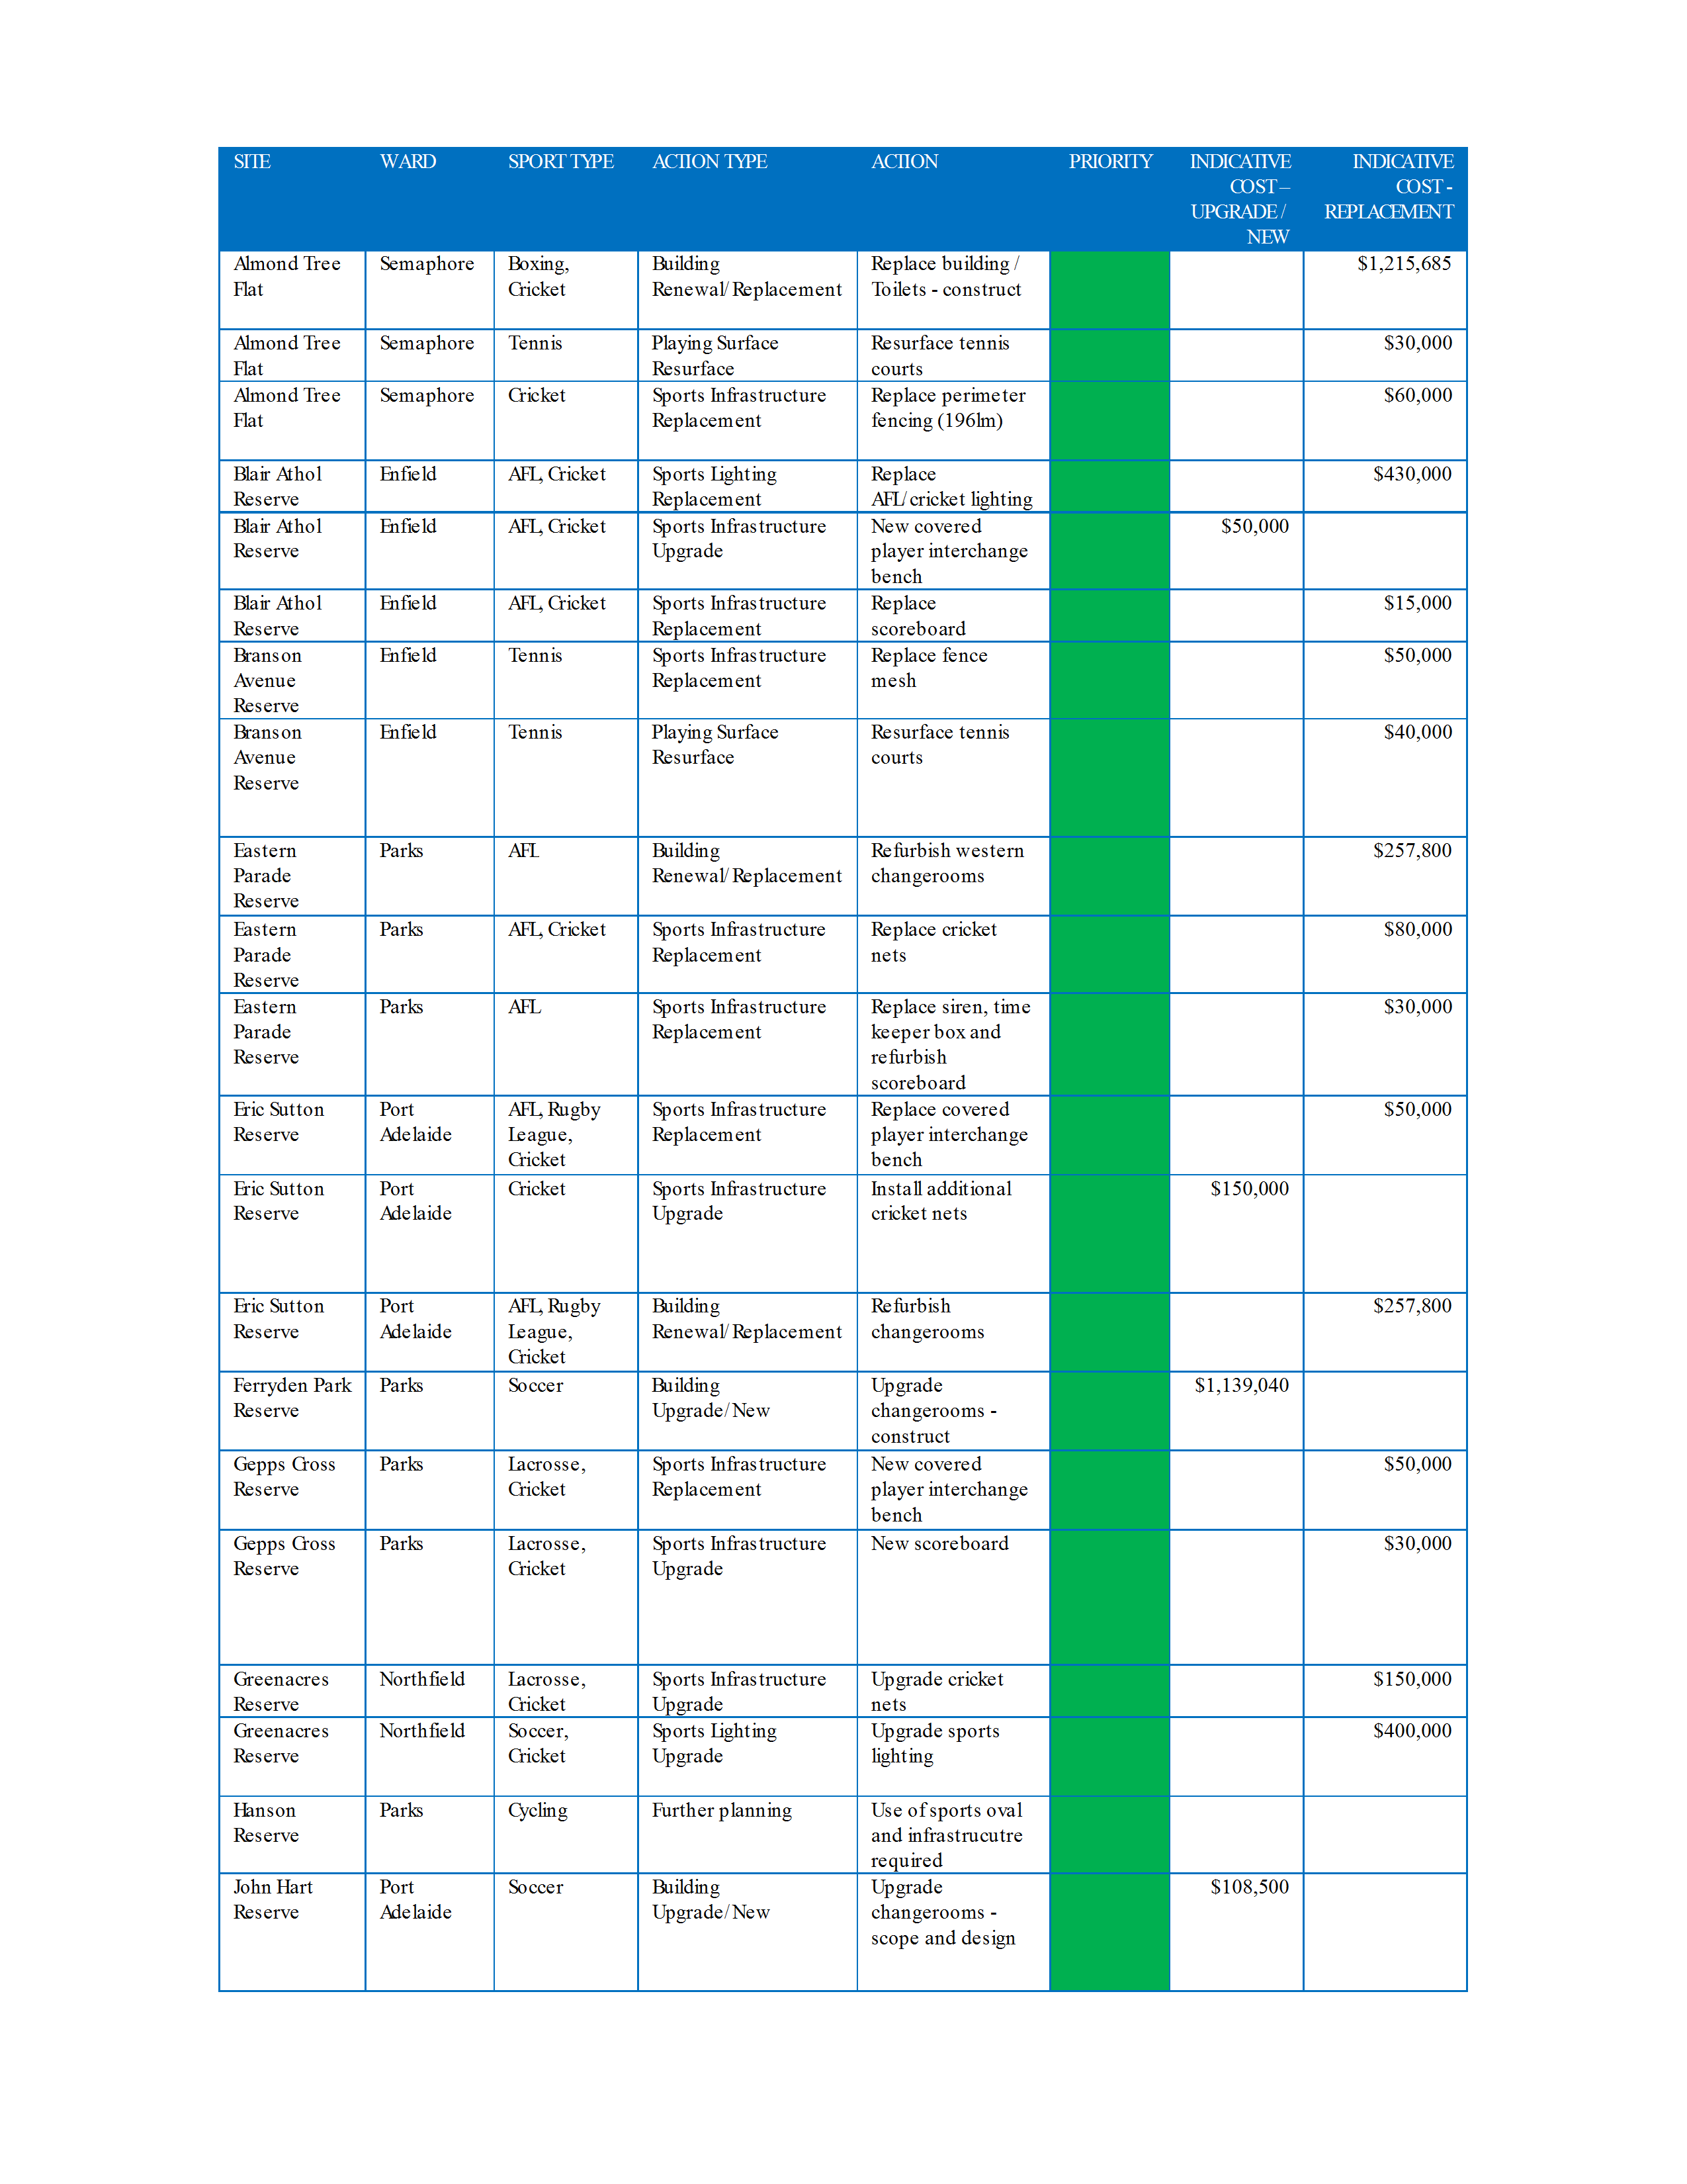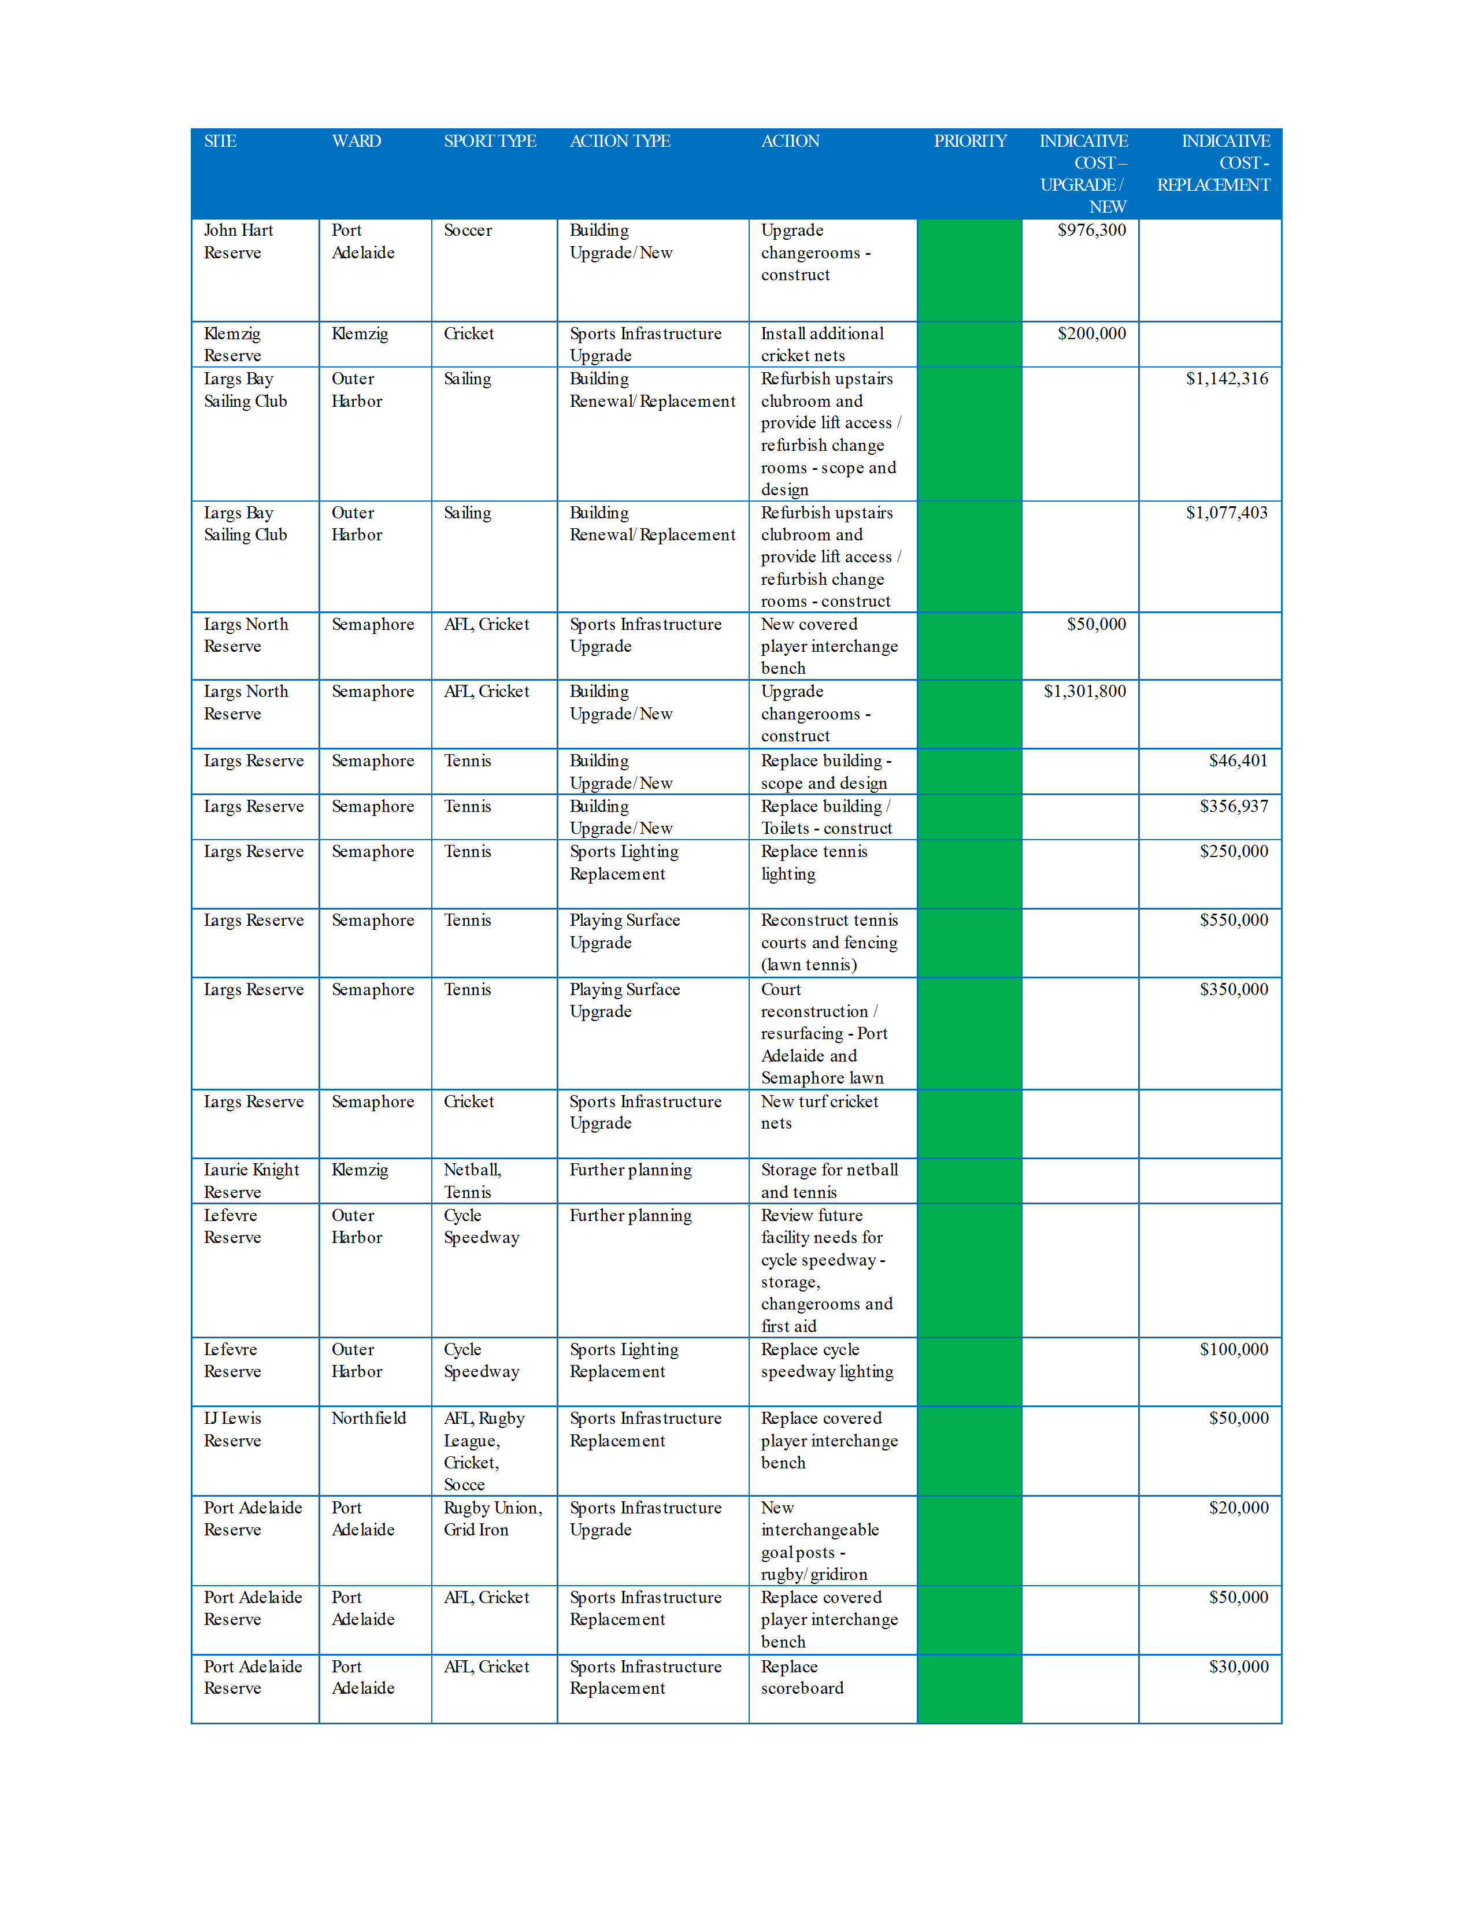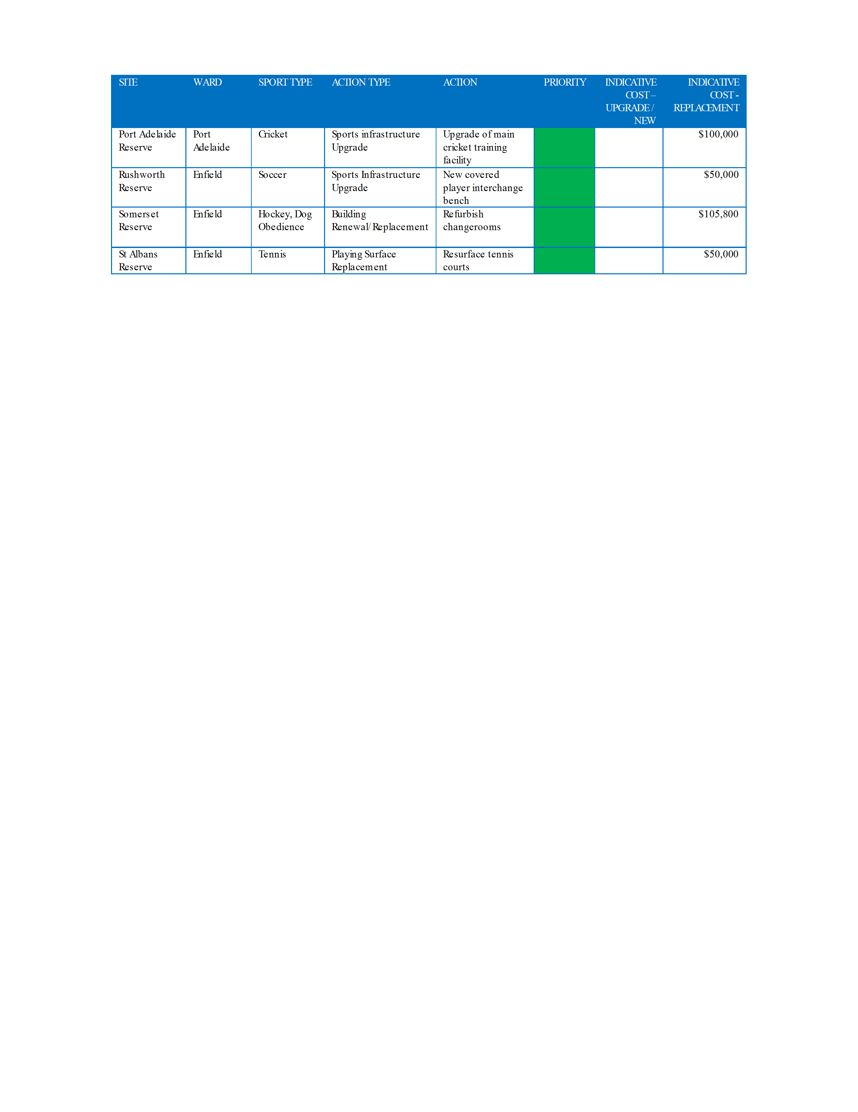
ATTACHMENT 2
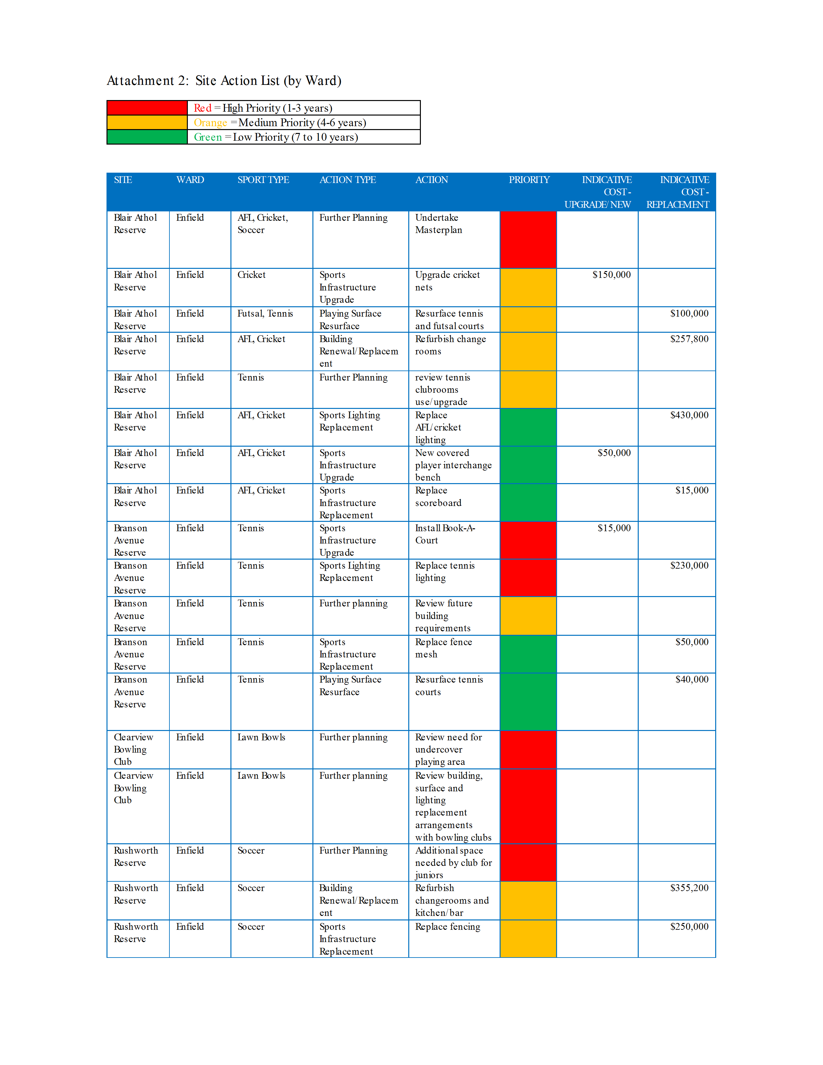
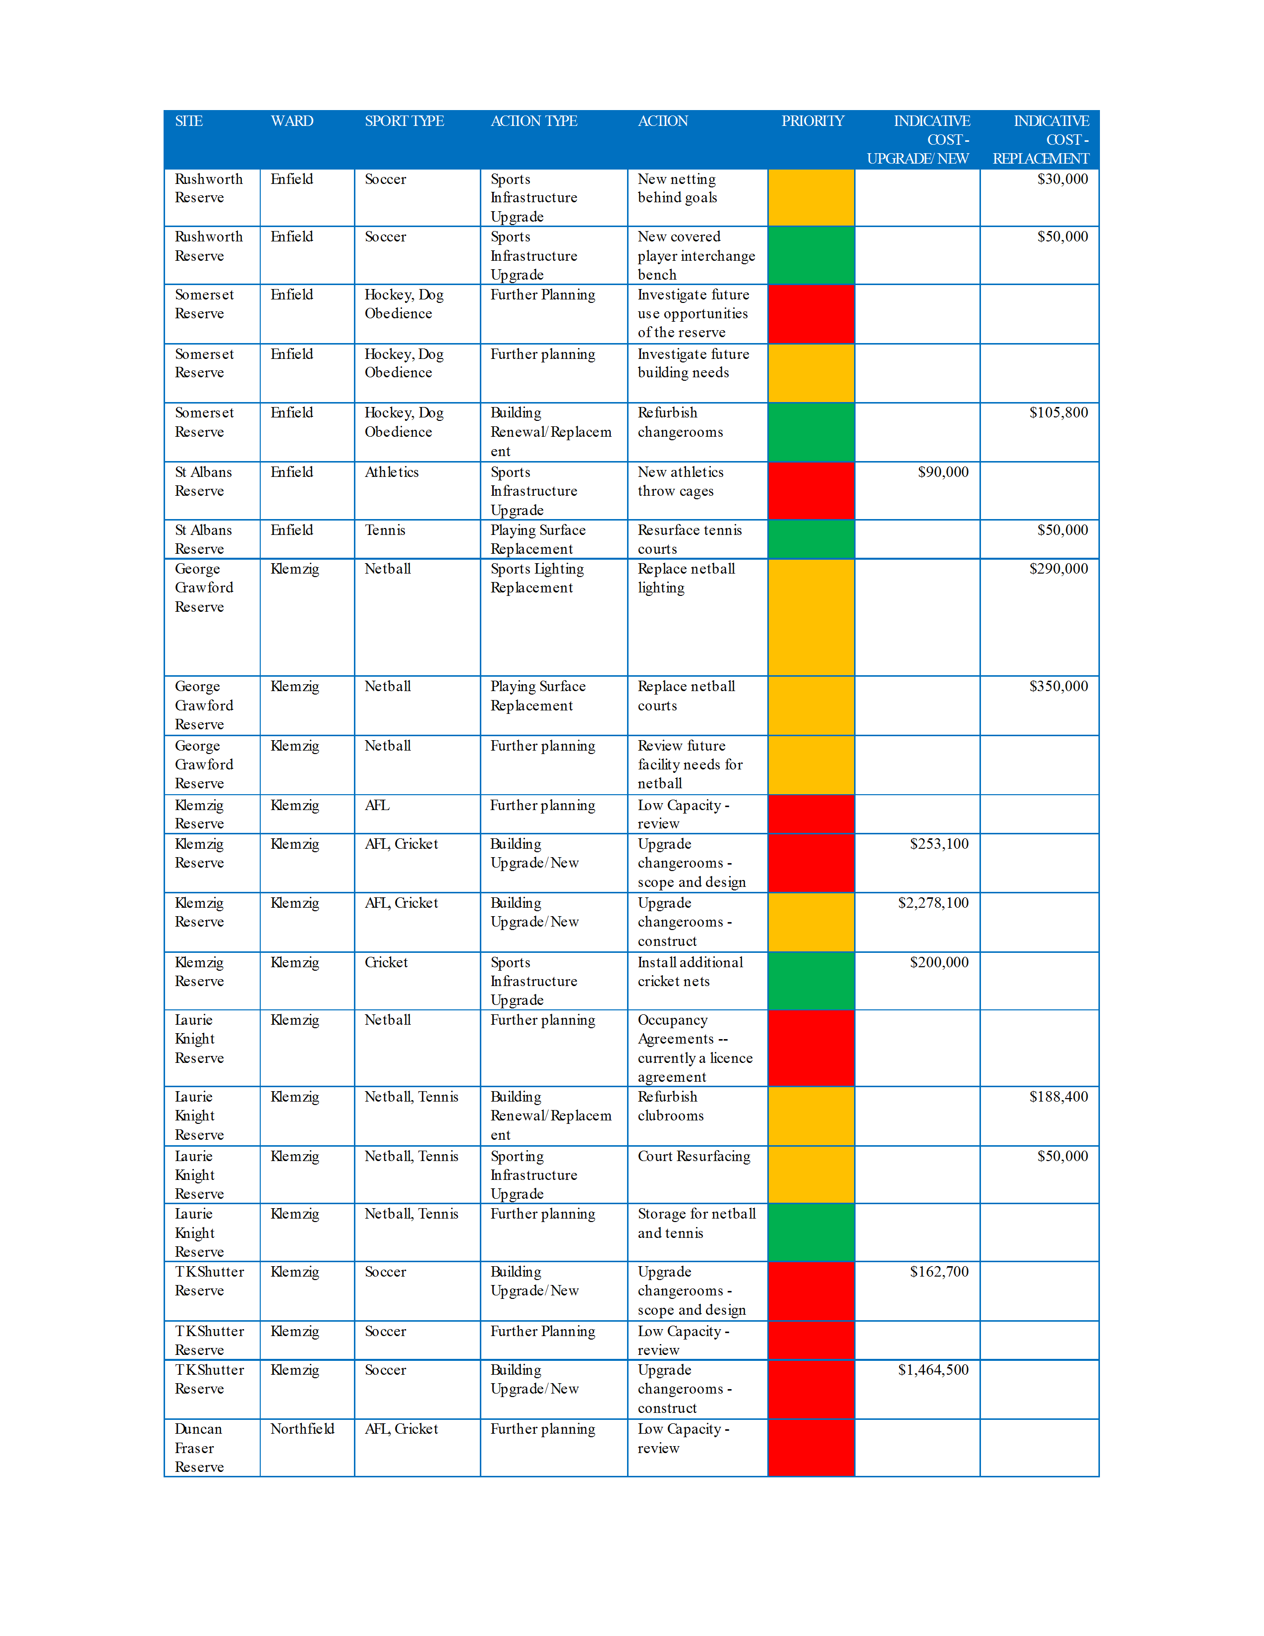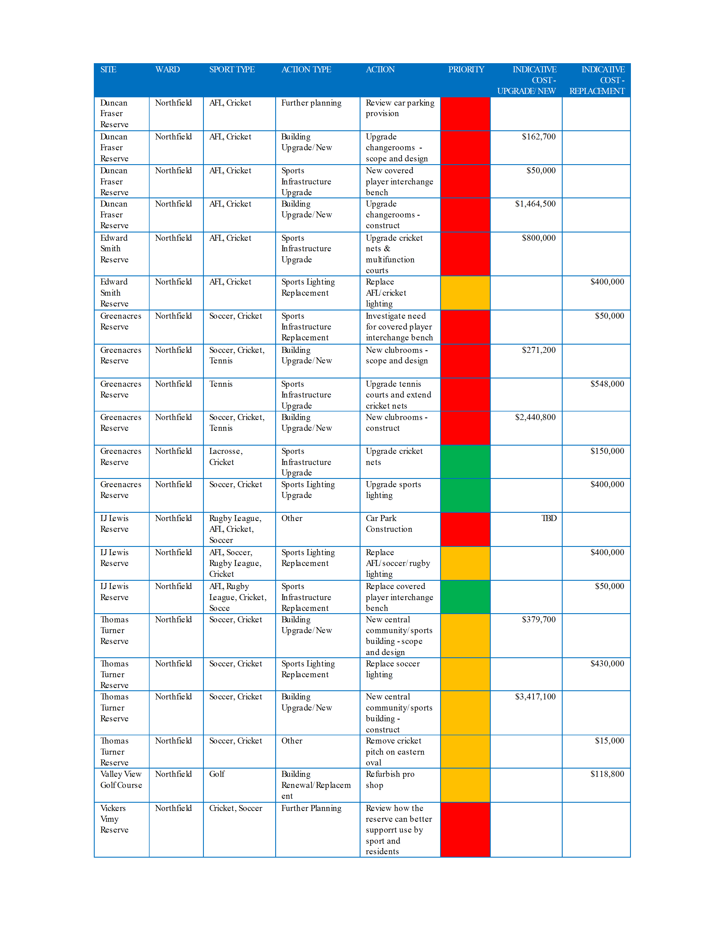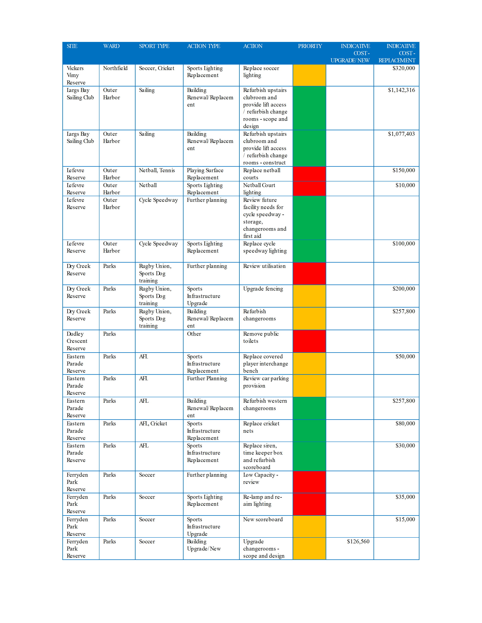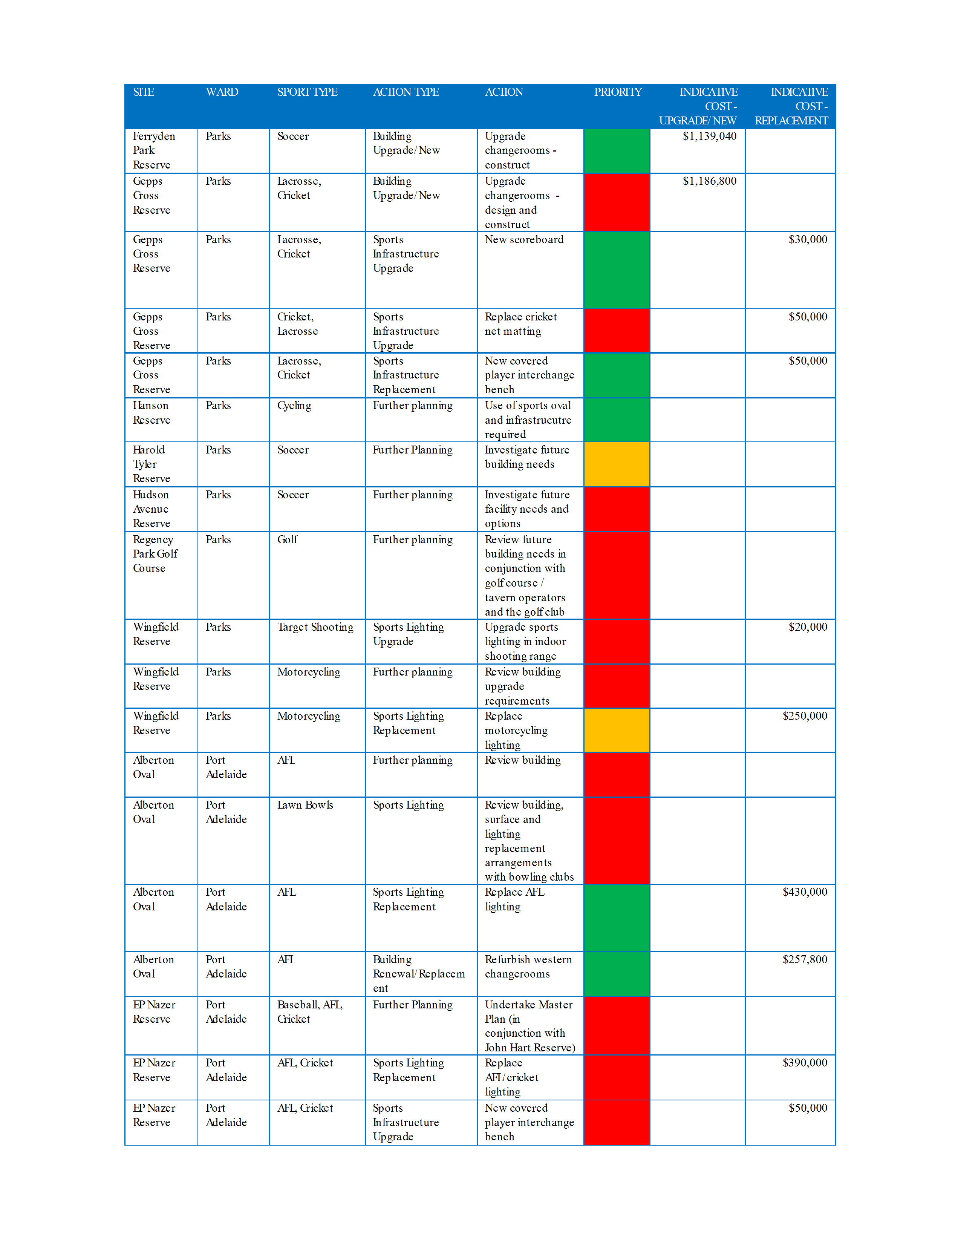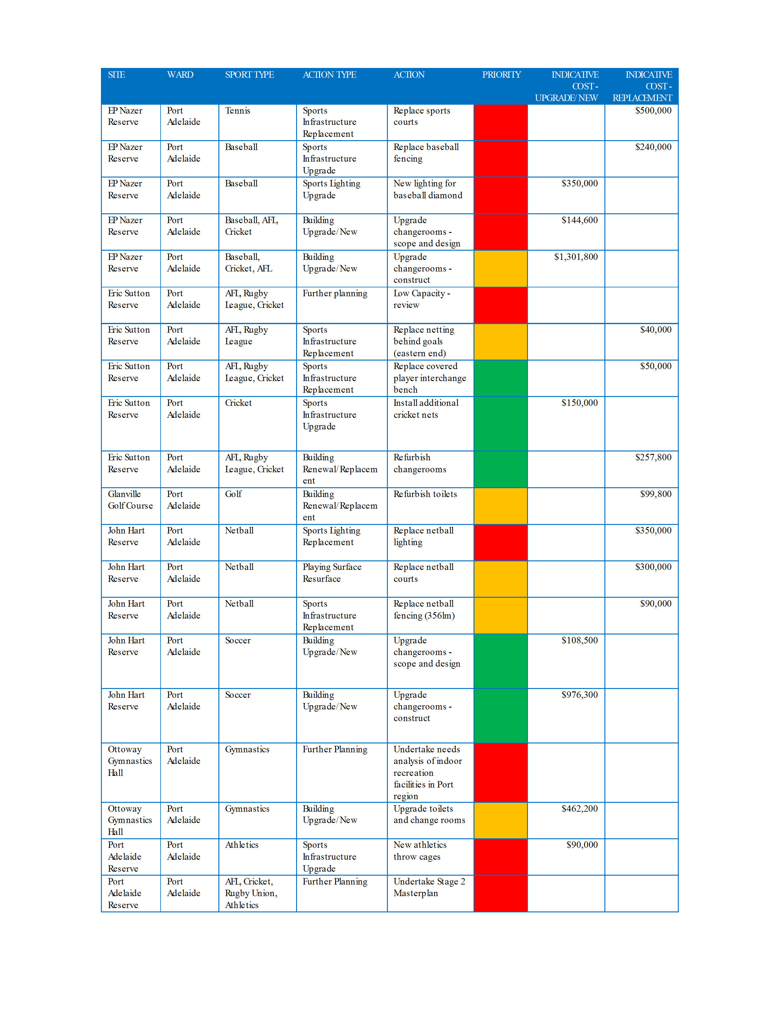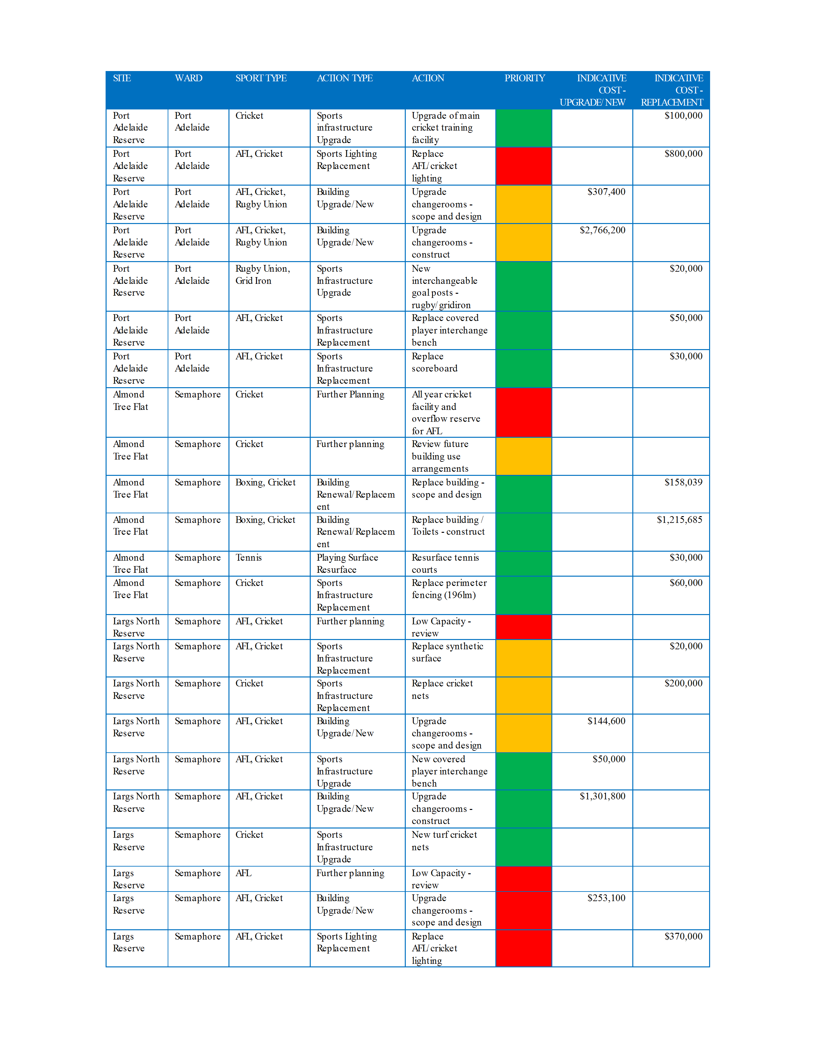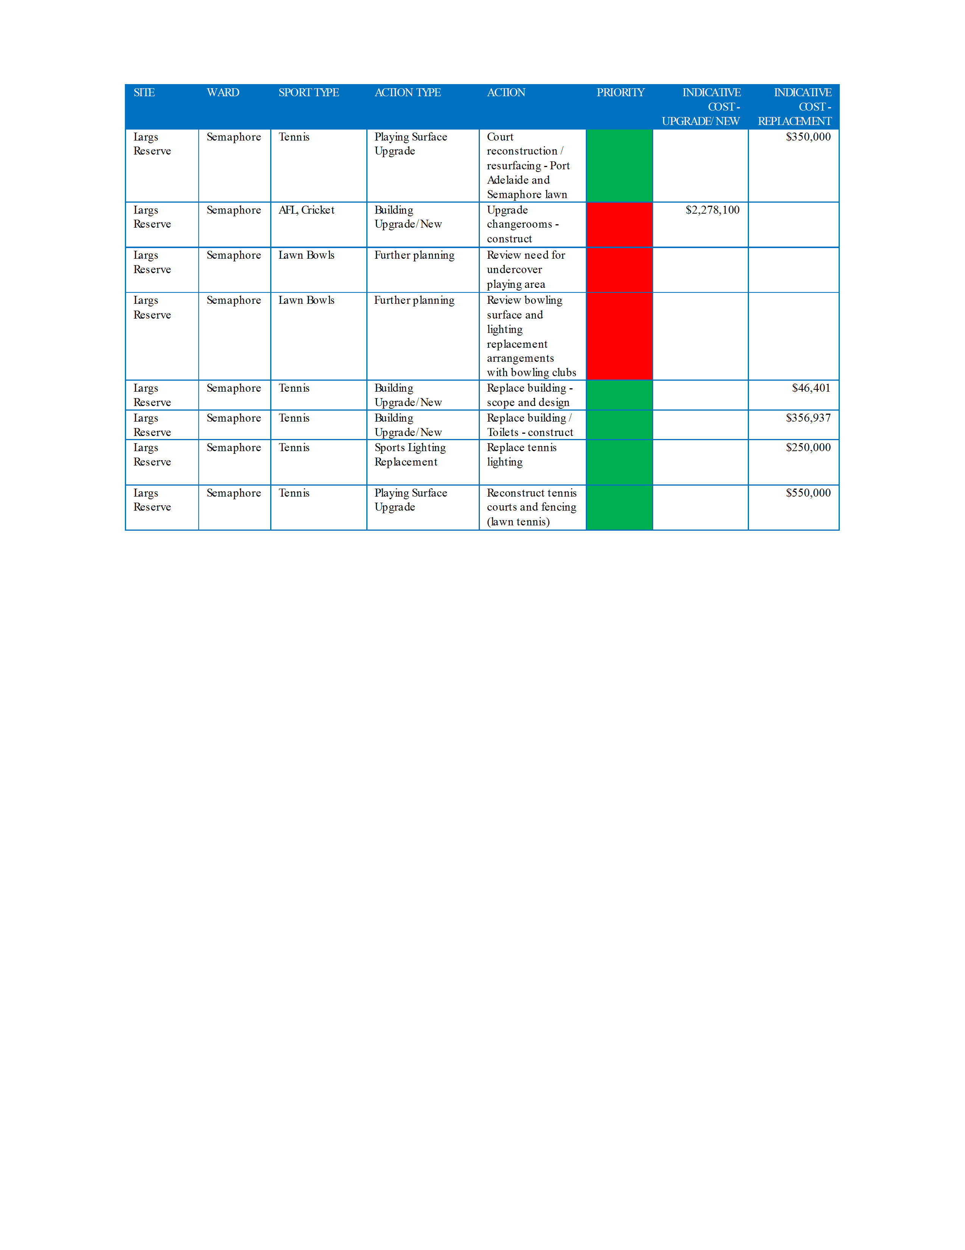
ATTACHMENT 3
